%% Linear Algebra: G.Strang, ” Differential Equations and Linear Algebra”, Wellesley- Cambridge Press,2014.

Chapter 4 to Chapter 8

1. Linear Equations and Inverse matrices
   1. Two Pictures of linear Equations
   2. Solving linear Equations by Elimination
   3. Matrix Multiplication
   4. Inverse Matrices
   5. Symmetric Matrices and Orthogonal matrices
2. Vector Spaces and Sub Spaces
3. Eigenvalues and Eigenvectors
4. Applied mathematics and ATA
5. Fourier and Laplace Transforms

%% 2 Semester

1. Linear Equation and Inverse matrices
   1. Two Pictures of linear equations

* Linear Equations (1)

1. Rows calculations
2. Columns calculations

To find the combination of those vectors that equals the vector on the right

* 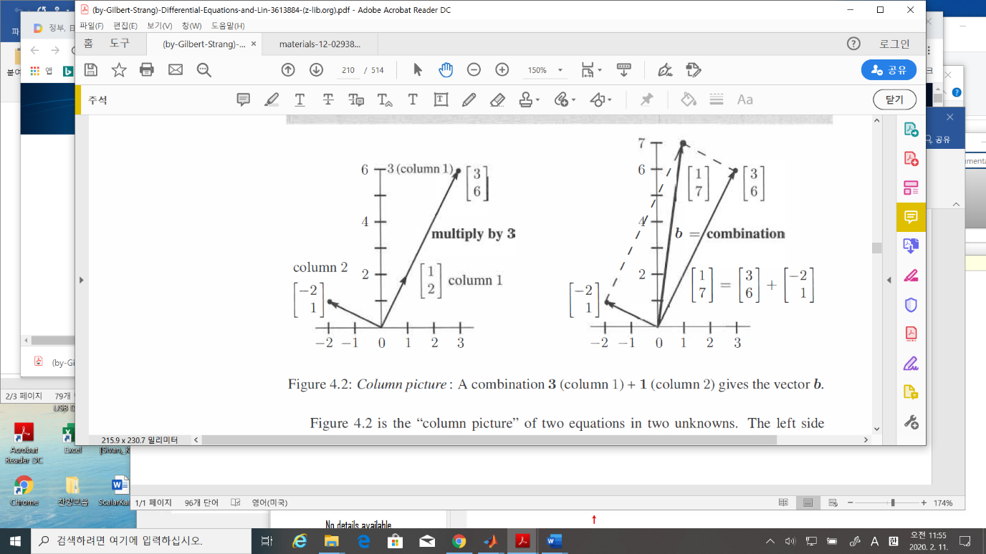
* Scalar multiplications
* Vector additions
* Linear Combination of the 2 columns
* The coefficient of (1)
* Dot products
* Linear combination
* Def: The dot product of is the number
* Number of Solutions of a linear equations:
* Unique solution

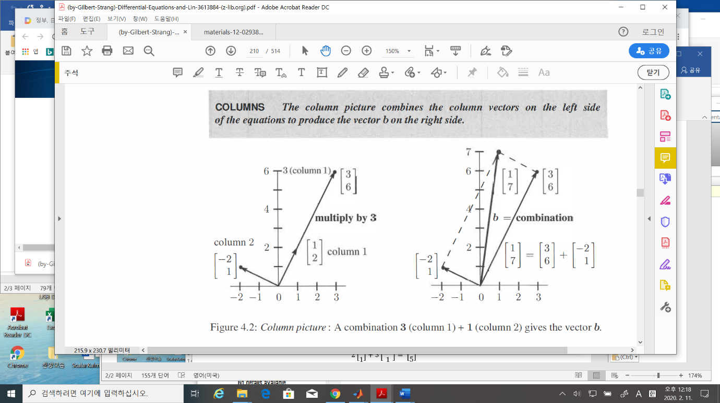

* No solution, infinite many solution

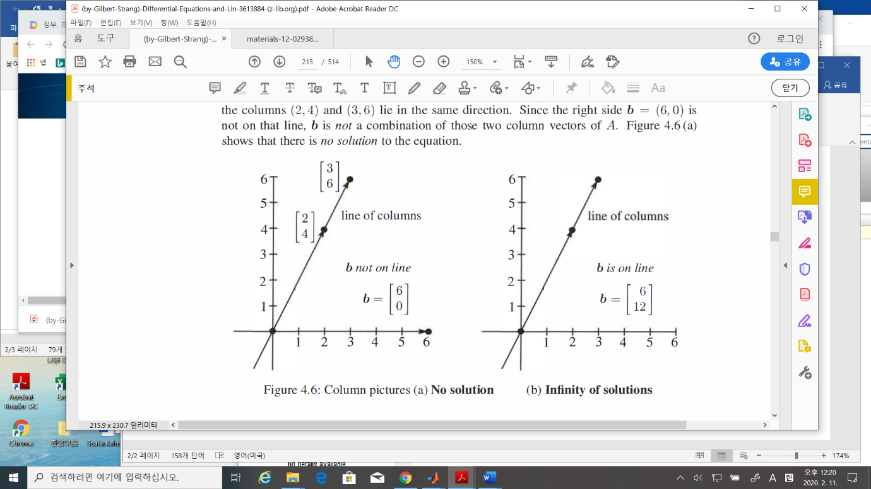

* 🡪 how many solutions?
* 🡪 how many solutions?
* Independence 🡪 later
  1. Solving linear equations by elimination
  2. Matrix Multiplication
* Multiply A times each column of B to get a column of AB

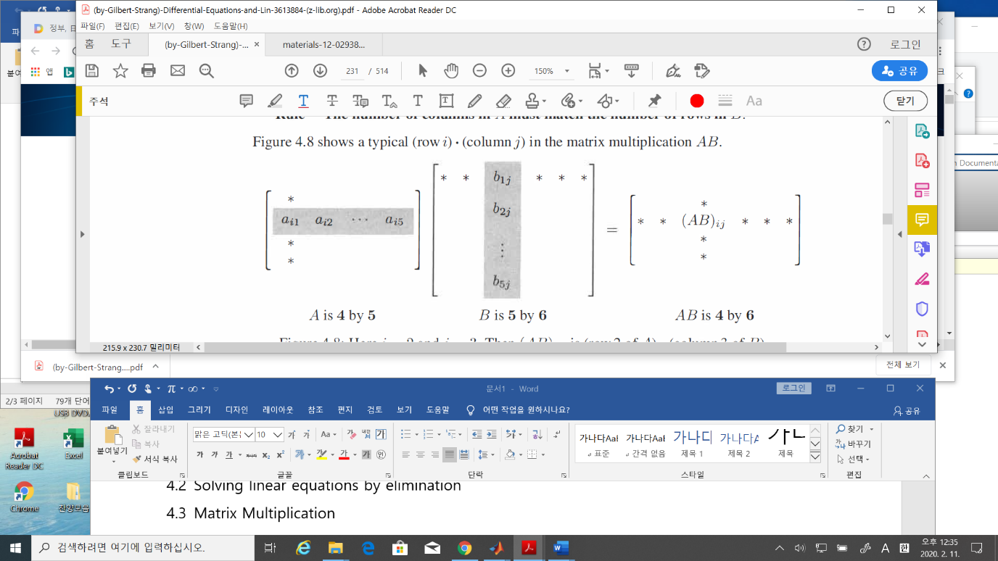

* Identity matrix
* Inverse matrix :
* Multiple of multiplications of Matrices
* Matrix formula
* Power of matrix

If p, q are integers

* 1. Inverse matrix
* Def. The matrix A is invertible if

1. The inverse matrix is unique
2. If A is invertible,, the one and only solution to is
3. Suppose there is a nonzero vector such that Then A cannot have an inverse.
4. A is invertible if and only if the determinant is not zero

* The inverse of a product AB
  1. Symmetric matrices and orthogonal matrices
* Def. Transpose of A

1. Properties

* Def: Symmetric matrix

1. is always an symmetric matrix for any matrix
2. Every symmetric matrix have real eigenvalues and orthogonal eigenvectors.

* Orthogonal matrix

1. Example

* Check ,,

1. The columns of an orthogonal matrix are orthogonal vectors.
2. If are orthogonal, so is their product

* Problems due next Tuesday(02/18)

P.1 Find an example

P.2 Today’s matlab example

1. Write a program to calculate
2. Run the program to get AB, and
3. Calculate the determinant of AB,A, and B(hint: det(A))

In Gilbert,

Chapter : 4.1 problem 9 , 28,

Chapter: 4.2 problem 5

Chapter: 4.3 problem 6, 14 (if false, please show the examples), 17,32,33

Chapter: 4.5 problem 1, 19

1. Vector Spaces and Sub-Spaces
   1. The Column space of a Matrix

* Def: Vector space

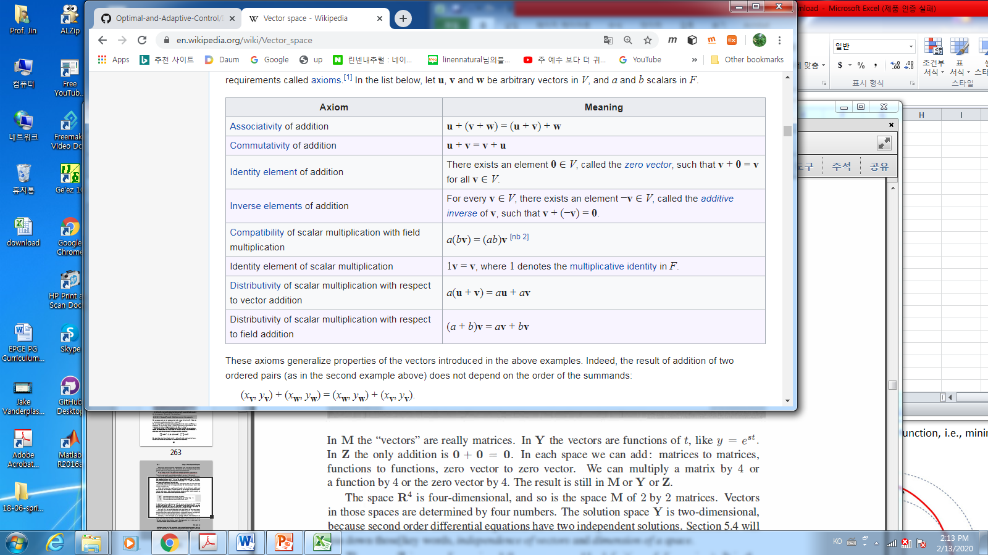

* Examples

The vector space of all real 2x2 matrices

: The vector space of all solutions to

The vector space that consists only a zero vector.

* Def: Subspaces

A subspace of a vector space, denoted by , is a set of vectors(including 0) that satisfies two requirements: If and are vectors in the subspace and is any scalar, then

1. (ii)

* Facts:

1. Every subspace contains the zero vector
2. Line through the origin are also subspaces

* Examples
* Def: The column space, , consists of all combinations of a columns,
* Fact: The system is solvable iff

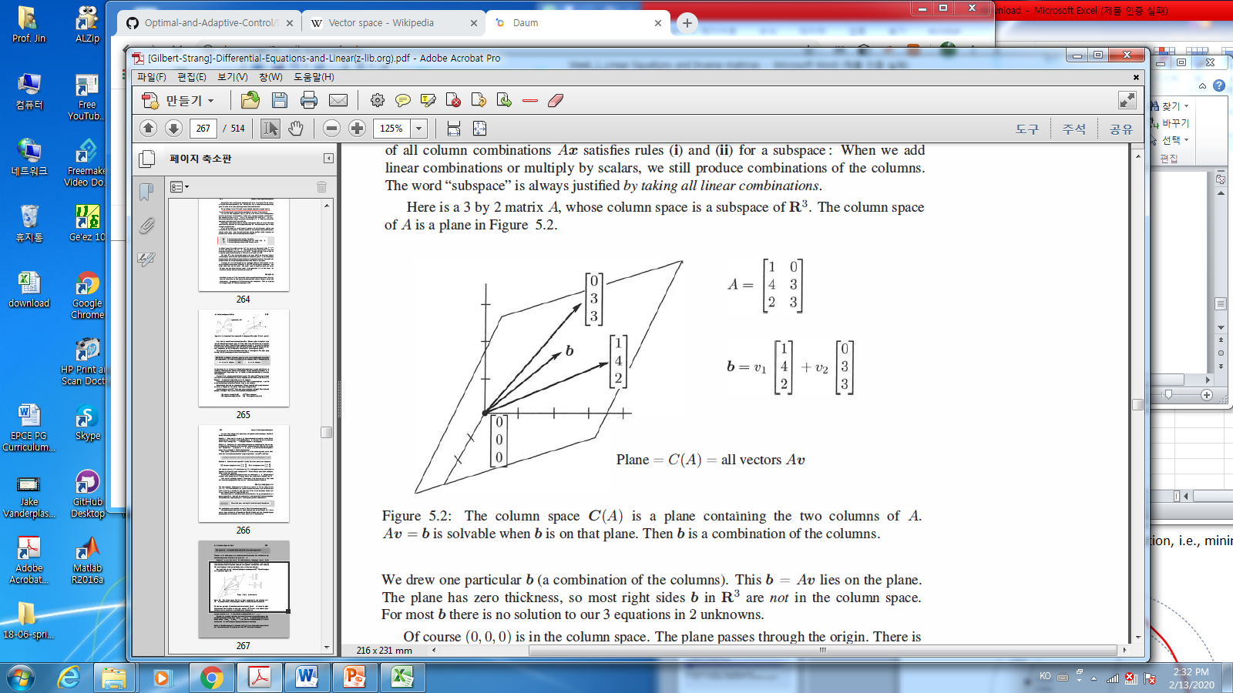

* 1. The null space of A: Solving
* Def: The null space of A, denoted by , consists of all solutions to
* Example: page.262
* Span of vectors
* Facts: The nullspace is a subspace
* Facts: **The central Idea**

1. The dimension of C(A) = rank of matrix = The number of independent column vectors.
2. The dimension of